

**A m a z o n P a n t r y**

**Business Analyst Capstone Project**

**By M ANAND**



ABC





ABC

**Enhancement of ABC Company App or**

**website to include new feature called ABC Pantry**

**Overview and Summary**

* ABC Company is the world’s leading online e-commerce company. They started by selling books and now have a presence across the world selling more than 6 million items globally.
* Most of the products that dominate ABC Company’s sales are non-essential products like fashion products, electronic gadgets, mobile phones, beauty products, books and home furnishings. But ABC Company has realized that every household will need daily essential products like cereals, snacks, beverages, cleaning products, grooming products and so on.
* ABC Company is seeing a huge market globally in Daily Essential Products and wants to venture into this side of business.
* ABC Company decided to create a new feature known as ABC Pantry which would sell daily essential products. This would be an additional enhancement in the current website/app.
* This would be ABC Company’s foray into daily essential products which are regular consumption products and would lead to repeat sales every month.
* ABC Company has invited Business Analysts trained at Simplilearn to capture the requirements for the creating this software.

**Project Task: Week 1**



**ABC**

**Identifying Stakeholders – The list of the Stakeholders**

**of the Amazon Pantry are as follows:**

* **ABC Company Management**: The management team of ABC Company holds a significant stake in monitoring the project's progress, ensuring that it aligns with the company's objectives, and monitoring the overall success of the ABC Pantry feature.
* **Project Managers**: The project managers responsible for the ABC Pantry project are stakeholders in the monitoring knowledge area. They are accountable for monitoring the project's execution, tracking milestones, identifying and addressing any issues or risks, and ensuring the project stays on track.
* **Development Team**: The development team involved in implementing the ABC Pantry feature will be responsible for monitoring the progress of their work, ensuring that the development tasks are completed according to the agreed-upon timelines and quality standards.
* **Quality Assurance Team:** The quality assurance team members are stakeholders involved in monitoring the quality of the ABC Pantry feature. They monitor the development process, conduct testing and reviews, and ensure that the final product meets the required quality criteria.
* **Advertising Team:** The advertising team responsible for displaying advertisements within the ABC Pantry feature is a stakeholder in the monitoring knowledge area. They monitor the performance and effectiveness of the advertisements, collect data on customer interactions, and make necessary adjustments to optimize revenue generation.
* **Customer Support Team:** The customer support team is responsible for monitoring customer feedback, inquiries, and issues related to the ABC Pantry feature. They ensure customer satisfaction by addressing concerns promptly and providing support as needed.
* **Users (Customers):** The users or customers of ABC Company who utilize the ABC Pantry feature are also stakeholders. Their feedback and usage patterns will be monitored to assess the success of the feature and make improvements based on their needs and preferences.
* **Data Analytics Team**: A data analytics team may be involved in monitoring and analyzing data related to user behavior, product sales, advertising revenue, and other key metrics. They provide insights and recommendations for optimizing the ABC Pantry feature's performance.

**Create As-Is and Future Process map (using flowcharts)**



ABC

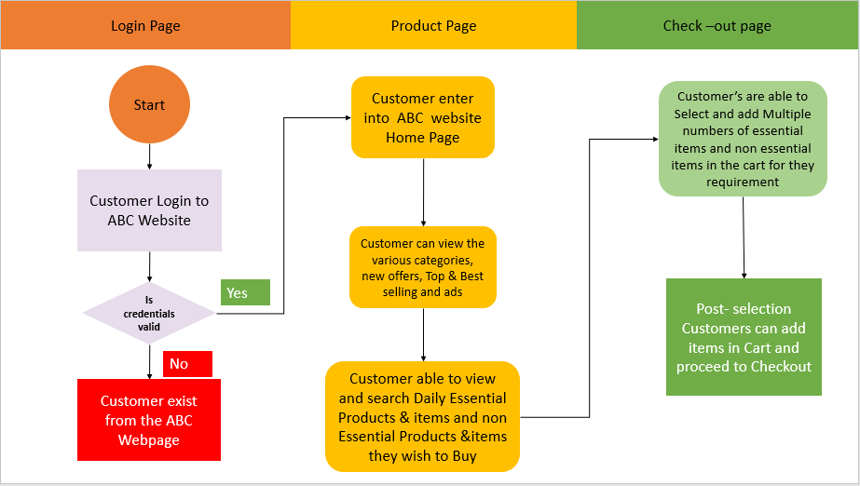

a) The above mentioned is as-is Process Map of existing ABC Company’s Website.

b) The below mentioned is the Future Process Map of ABC Company’s Website along

with ABC Pantry.

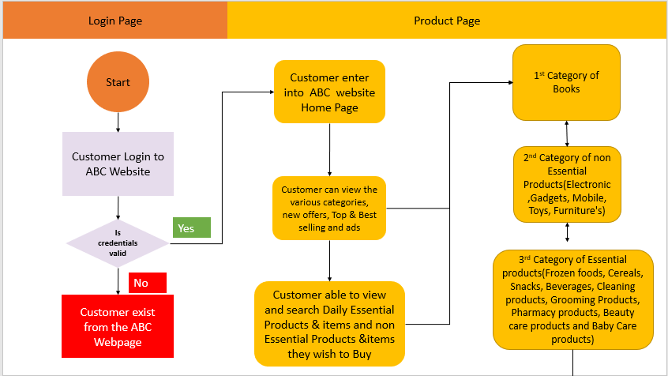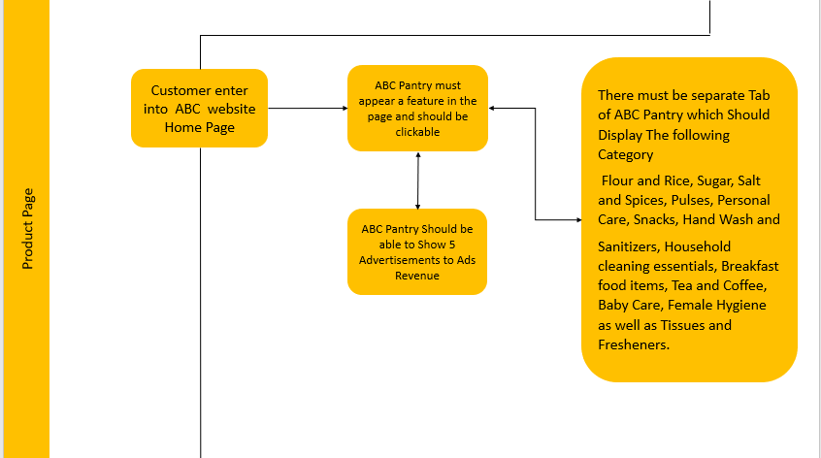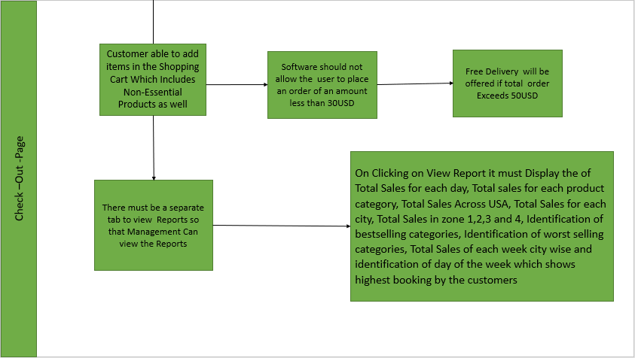

**3) As a Business Analyst working on this project, find out the scope of the feature ABC**

**Pantry. Write down the main features that need to be developed**

a) ABC pantry would sell daily essential products like cereals, snacks, beverages, cleaning

products, grooming products and so on

b) ABC pantry is one of the sub-features of the ABC website

The main features that need to be developed in ABC Pantry are as follows:

a) ABC Company’s website must have a separate feature of ABC Pantry

b) There must be a separate tab of ABC Pantry inside the ABC website which is

clickable and should display the new range and various categories of Products

c) ABC Pantry feature must be clearly visible in both website and app

d) When the user clicks on the ABC Pantry, it must display the various daily essential

items categories of Flour and Rice, Sugar, Salt and Spices, Pulses, Personal

Care, Snacks, Hand Wash and Sanitizers, Household Cleaning Essentials, Breakfast

Food Items, Tea and Coffee, Baby Care, Female Hygiene as well as Tissue and

Fresheners

e) ABC Pantry should be able to show five advertisements to earn the advertising

revenue

f) The software should not allow the user to place an order of amount less than

30USD

g) Free delivery will be offered if the total order exceeds 50USD

h) There must be a separate section or tab of viewing reports which displays the

following information to the Management:

-Total sales for each day

-Total sales for each product category

-Total sales across USA

-Total sales for each city

-Total sales in zone 1,2,3 and 4

-Identification of Best-Selling categories

-Identification of worst selling categories

-Total sales of each week city wise

- Identification of which day of week shows highest booking by customer

**4) Write the in-scope and out-of-scope items for this software**

In-scope requirements of the software are the requirements which lie inside the

Boundary

While out-scope requirements are those which lie outside the boundary of the software.

Some of the In-scope requirements of the software are as follows:

a) ABC Company’s website must contain the feature of ABC Pantry for selling daily

essential products

b) Inside the web page of ABC Website, there should be one menu page for displaying

the books, non-essential products and Daily Essential Products.

c) The non-essential products in ABC Website must be classified as fashion, electronic

gadgets, mobile phones, beauty products, books and home furnishings.

d) The daily essential products in ABC Website must be classified as Flour and

Rice, Sugar, Salt and Spices, Pulses, Personal Care, Snacks, Hand Wash and

Sanitizers, Household cleaning essentials, Breakfast food items, Tea and Coffee, Baby

Care, Female Hygiene as well as Tissues and Fresheners.

e) The ABC Pantry should be able to show five advertisements to earn the advertising

revenues.

f) Only the Management of the ABC Company can view the reports at the end of the

day. The reports must contain the information of Total Sales for each day, Total sales

for each product category, Total Sales Across USA, Total Sales for each city, Total

Sales in zone 1,2,3 and 4, Identification of bestselling categories, Identification of

worst selling categories, Total Sales of each week city wise and identification of day

of the week which shows highest booking by the customers

**Some of the out-of-scope items for this software are as follows:**

a) If the view reports section is visible to any alternate Management except ABC

Management, then it comes under out-of-scope requirement

b) If the ABC pantry software is displaying more than five advertisements’, then it also

comes under out-of-scope requirement

c) The ABC Pantry software allowing the user to place an order of an amount less

than 30 USD is also one of the out-of-scope requirements.

d) If the software is allowing free delivery for the total orders less than equal to 50

USD is also a part of out-of-scope requirement

e) The ABC Pantry software presence in any alternate city except Chicago, New

York, Seattle, Washington, Kanas City, San Jose, Dallas, Miami, new-Orleans, Phoenix, Jersey City and Madison comes under Out-of-scope requirement.

**5) Write out the business requirements, both functional and non-functional Requirements**

**Functional Requirements**: are the requirements which must be present in the

product. These are the functions which developer must enable to accomplish their tasks

Some of the functional requirements of automated ABC software are as follows:

a) The Web Page of ABC software must have a new feature of ABC Pantry

b) This ABC Pantry tab or section must be clickable and would open a new range and

categories of product

c) The ABC Pantry feature should be visible in both website and app

d) When the user clicks on the ABC Pantry, it must display the logical grouping of

products for each customer.

e) While clicking on ABC Pantry, entire list of daily essential items must be visible in

front of user.

f) The categories which are present in the daily essential items are Flour and rice, Sugar, Salt and Spices, Pulses, Personal care, Snacks, Hand Wash and

Sanitizers, Household cleaning essentials, Breakfast food items, Tea and Coffee, Baby Care, Female Hygiene and Tissue and Fresheners

g) When the user clicks on ABC Pantry, a detailed drop down must appear in front of the

customers/users. The first drop down should be able to show the five advertisements

while the second drop down shows the certain offers that are created for customers

h) The software should not allow the user to place an order of amount less than 30USD.Individual items can be added in the shopping cart which are less than 30USD, but the total price has to exceed 30USD.

i) There must be a provision of Free delivery in the software for the orders which

exceeds 50USD

j) There must be a separate section of tab of viewing reports in the ABC Pantry Software

which is clickable. When the Management of ABC Software clicks on the reports tab, a detailed format of following reports which contains the

Total Sales for each day, Total Sales for each product, Total Sales across USA, Total sales for each city, Total sales for zones 1,2,3 and 4, identification of bestselling categories, identification of

worst selling categories, Total sales for each city and identification of day of week

showing highest booking by customers should be visible to the Management of ABC

Software.

**Non-Functional Requirements**-: are the quality of the system. These are the quality

attributes. They are the support features. Some of the Non-Functional Requirements of

the software are as follows:

a) Availability: The ABC automated software must be available for various

customers of Chicago, New York, Washington, Seattle, Kanas City, San Jose, Dallas, Miami, New Orleans, Phoenix, Jersey City and Madison

b) Compatibility: The software must handle the registrations of various customers

of Chicago, New York, Seattle, Washington, Kanas City, San Jose, Dallas, Miami, New Orleans, Phoenix, Jersey City and Madison

c) Usability: The software is easy to use for natives of above-mentioned cities

d) Security: The automated ABC Software along with ABC Pantry can handle threat, viruses and malicious attacks

e) Localization: The UI (user-interface) of the software is designed in English Language and the price of items are mentioned in USD

f) Extensibility: The software can incorporate new features according to

Stakeholder requirements

g) Compliance: Only the citizens of Chicago, New York, Seattle, Washington, Kanas City, San Jose, Dallas, Miami, New Orleans, Phoenix, Jersey City, Madison and the Management of ABC software can access the software. No other outsider apart from the above-mentioned cities can access the software as it will ask for credentials

h) Portability: Only the citizens or natives of the above-mentioned cities can access

the automated software on every desks. It must be portable and handy.

**6) Draw wireframes or mock screens for any two of the features. Use the technique**

**prototyping or wireframing that is taught in the training. You can use any of the wireframing**

**tools like Microsoft PowerPoint, Microsoft Word, Balsamiq, Sketch, Adobe XD, Adobe Illustrator, Figma, UX Pin, In Vision Studio, In vision Freehand, or Moqups.**

The wireframe of Daily Essential Items of Automated ABC Website along with ABC

Pantry using MS power point follows

1. ABC’s Website user Login /Sign page

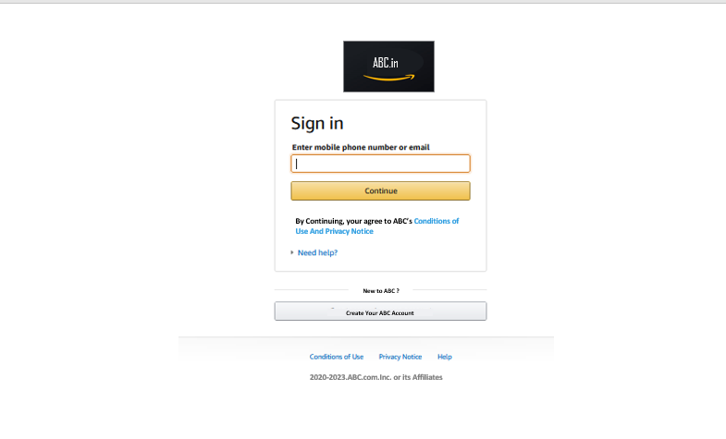

1. Home Page (ABC Home Page)

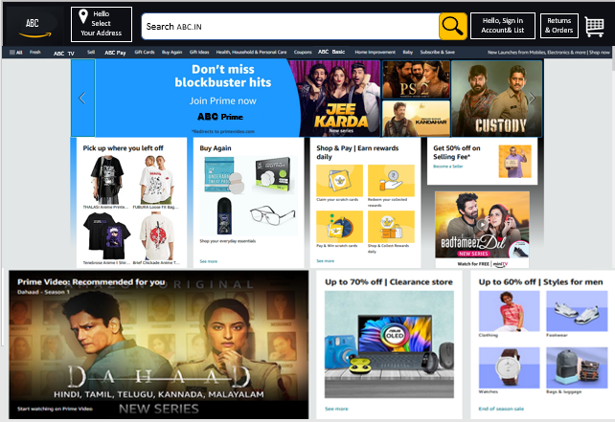

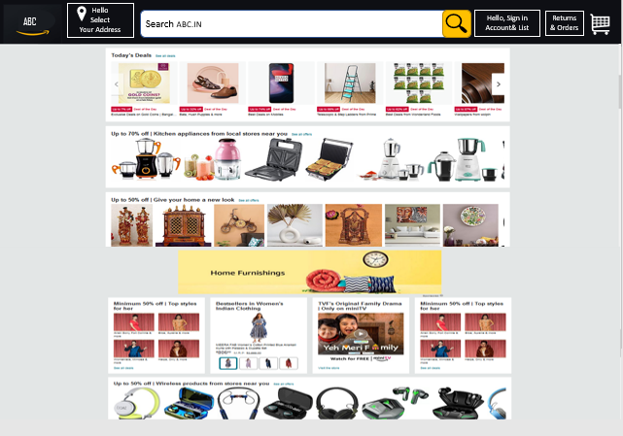

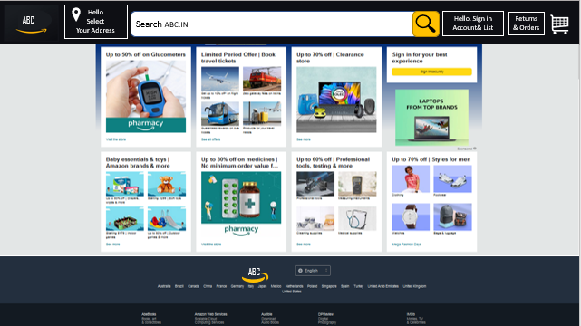

3.User/Account Details in ABC website

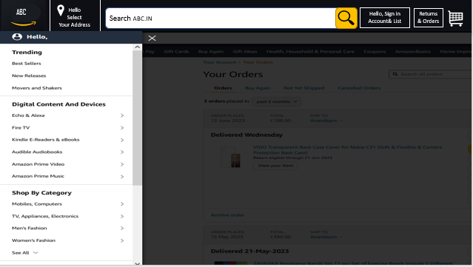

4.Ordering /add to cart Page in ABC Website

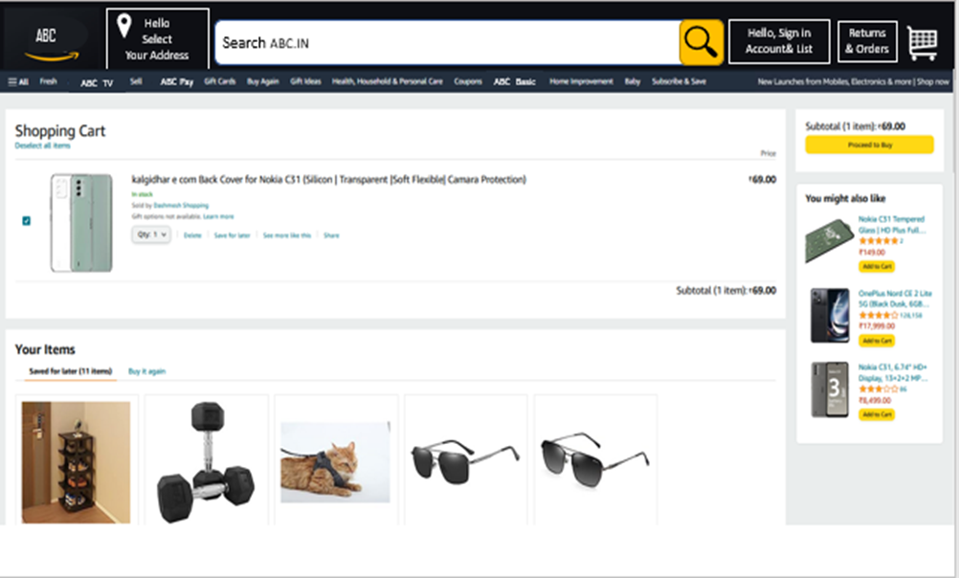

5.Chout out /Payment Page in ABC website

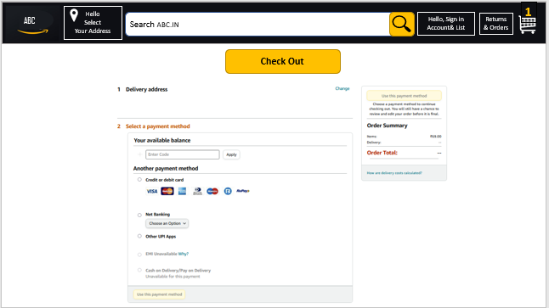

6.Order Details /Track your order in ABC website

